# **Pizza Sales SQL Queries**

1. KPI’s

1.Total Revenue



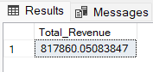

1. Average Order Value

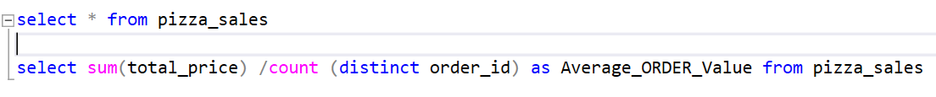



1. Total Pizza Sold

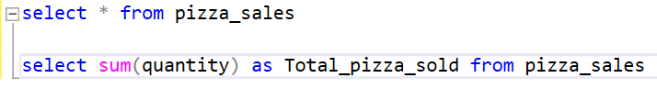

1. Total Orders Placed

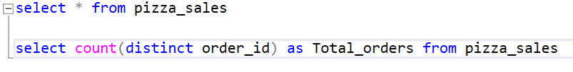

1. Average pizza per order

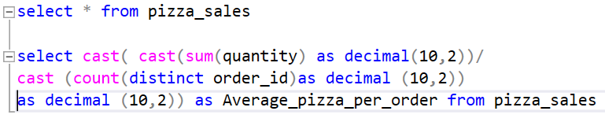

# **Problem Statement**

1. Daily Trends for total orders

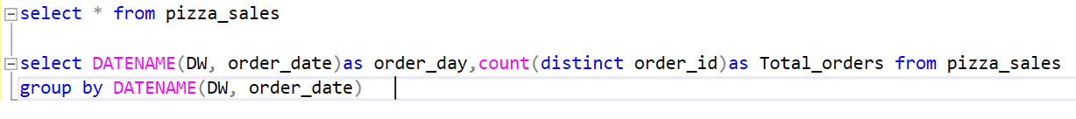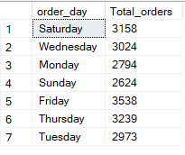

1. Monthly Trends of total orders

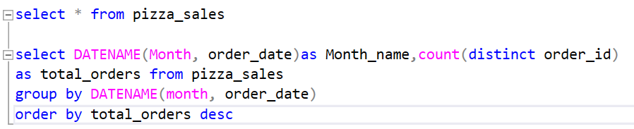

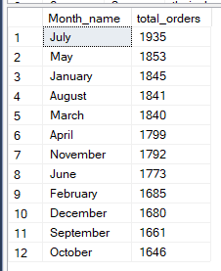

1. Percentage% of sales by pizza category

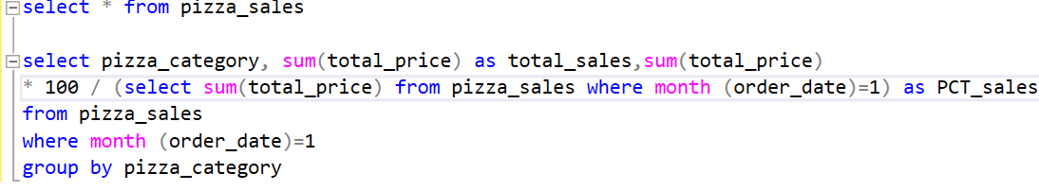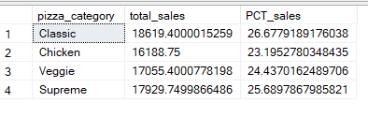

1. Percentage of sales by pizza size

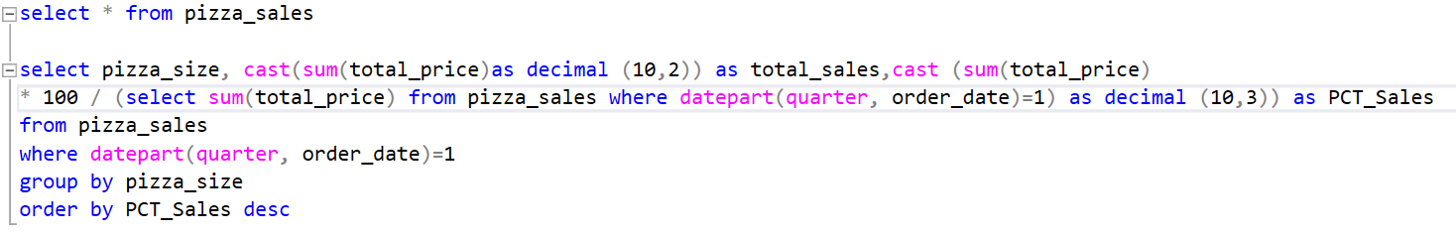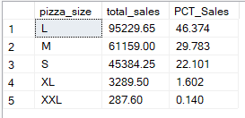

1. Top 5 pizzas by revenue

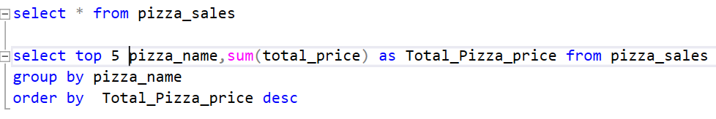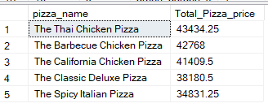

1. Bottom 5 pizzas by revenue

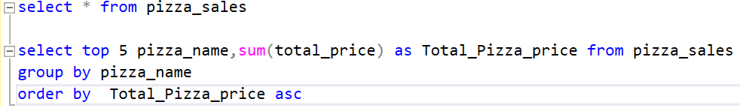

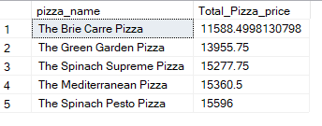

1. Top 5 pizzas by quantity

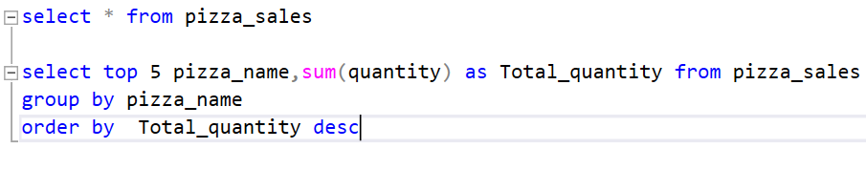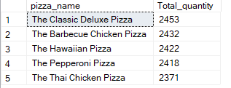

1. Bottom 5 pizzas by quantity

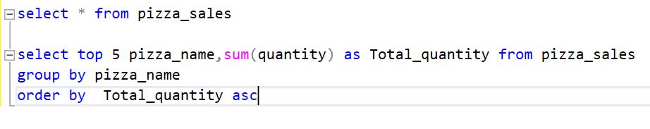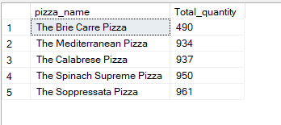

1. Top 5 pizzas sold by quantity

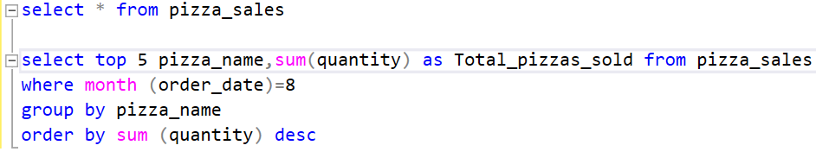

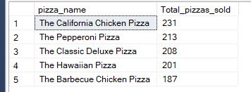

1. Bottom 5 pizzas sold by quantity

